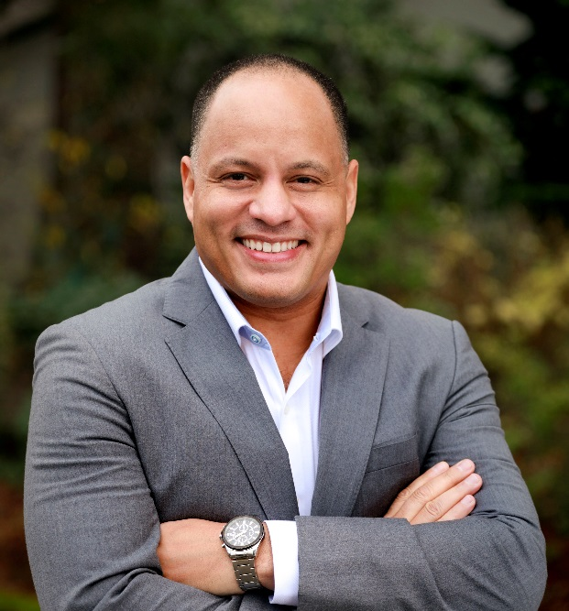
Shawn has more than 27 years of combined experience as a clinician, technician, manager, director and Sr. level Executive within the Perioperative/SPD/Tissue banking and medical device industry. He maintains certifications as a CRCST, CIS, CHL and is currently a 2019 candidate for a IAHCSMM Board of Directors seat. He began his career by serving in the US Army as a surgical tech which included training/working in Sterile Processing. This was followed by a lengthy career in biotech/tissue banking whereby he focused on training staff in accordance with FDA, OSHA, and AATB standards. He then took that regulatory/training experience back into healthcare by leading Sterile Processing department at one of the largest level 1 trauma centers in the southeast by focusing on training/competencies, restructuring sterile storage for increased efficiency in workflow, replacing antiquated equipment, HLD reprocessing consolidation, updating all policy and procedures to meet AAMI, AORN, CDC and TJC standards. Upon achieving transformational change at Grady Memorial Hospital, he obtained the entrepreneurial bug and co-founded a medical device manufacturing company focused on products and techniques that promotes SSI reduction, safety and productivity within Sterile Processing/Perioperative services. As President/Co-Founder, he led the company’s efforts in obtaining 510k clearance along with ISO 13485 w/CAMDCAS designation. He now has taken that combined unique healthcare experience into leading Stanford’s Lucile Packard Children’s hospital’s SPD in creating the model department which will include implementing ISO.

